COVID-19
PANDEMIC RESPONSE & SAFETY PLAN

Version  Number | Date | Document  Owner | Department | Approved By | Latest Revision Made
15 | 02-10-21 | Craig Sparks | Health & Safety | Pandemic Committee | Revised:  - Added Precautions for Meal and Break Periods  - Appendix 13
 |  |  |  |  | All changes are highlighted in YELLOW

Table of Contents
1. Introduction 3
a) Objective 3
b) Plan Integration 3
c) Activation 3
2. Organization & Responsibilities 4
Overall Structure 4
Corporate Response Team 4
Pandemic Committee 4/5
3. Monitoring External Communications 5
4. Communications 5
a) Senior Management Communications 5
b) Pandemic Alerts 5/6
c) Current Pandemic (COVID-19) Information 6/7
5. Prevention 7
a) Comply with Provincial and Federal Legislation 7
b) Complete Daily Health Screening 7
c) Maintain Proper Social/Physical Distance from Others 8
d) Precautions for Meal and Break Periods 8
e) Face Covers – Requirements on when and how to use 9-10
f) Hand Washing 11
6. Containment Activities 11
a) Cleaning 11
b) Offsite Work Capabilities 11
c) Management of Cases at Work 11
d) Travel 12
7. Treatment & Medical Assistance 12
a) Treatment 12
b) Medical Assisstance 12
8. Preparedness 13
a) Employee Awareness Training 13
b) Personal Planning Information for Employees 12
9. Return to Work 13
10. First Aid Procedure 14
11. Projects and Spare Vehicle Cleaning Requirements (APPENDIX 7 & 10) 15
APPENDIX 1 – Reference Material Summary 16
APPENDIX 2 – COVID-19 Warning Notice 17
APPENDIX 3 – COVID-19 Information Sheet 18
APPENDIX 4a – Corporate Response Team (CRT) 19
APPENDIX 4b –Pandemic Committee (PC) 19
APPENDIX 5 – COVID-19 Tracking 19
APPENDIX 6 - Suspected COVID-19 Health Case at Work 20
APPENDIX 7 – Personal COVID-19 Planning 21
APPENDIX 8 –COVID-19 Active Screening Sign-In Sheet 22
APPENDIX 9–COVID-19 Site Sanitation Checklist 23
APPENDIX 10–COVID-19 Spare Vehicle Inspection Checklist 24
APPENDIX 11–COVID-19 Confirmed Case Flowcharts 25
APPENDIX 12–COVID-19 How to create safe Social Circles/Bubbles/Cohort Groups 25
APPENDIX 13–COVID-19 Lunchroom and Breakroom Capacity Signs 26

Introduction

Objective

The objective of the Maple Reinders Pandemic Response Plan (PRP) is to manage the impact of a Pandemic crisis on employees and business activities using two main strategies:

  - Protect our staff, guests and the public
  - Containment of the disease by reducing spread within the business

Plan Integration

The PRP responsibilities, preparedness activities and response activities are integrated with the following plans and processes:

  - HSE Manual
  - Project Emergency Response Plans
  - Crisis Management Plan

Whenever possible, the PRP references support services and processes that already exist and identify activities and processes that need to be integrated across the company.

Activation

The activation of the Pandemic Contingency Plan consists of:

  - The activation of the Pandemic Committee
  - Corporate Response Team
  - Consultation with businesses and functions on critical processes, impacts and priorities.

Maple Reinders is committed to preparing and responding to the current Pandemic crisis and adequately protecting our employees, the public, and to continue to execute on essential services.

Organization & Responsibilities
The PRP is maintained and updated by Maple Reinders’s management team with input and support from all departments as required. The following outlines key responsibilities by department or area as detailed in the PRP:

  - Corporate Response Team is the lead for coordinating activities related to Public Health Emergencies.
  - Pandemic Committee is responsible for monitoring for health emergencies and making recommendations to the Corporate Response Team.
  - Regional management teams are responsible for communicating the plan to their teams.
  - Corporate Response Team maintains the response structures.

Overall Structure

Corporate Response Team (CRT)
The Corporate Response Team (CRT) is ultimately responsible for the steps taken during the current Pandemic. These decisions include but are not limited to:
    - Employee protection steps
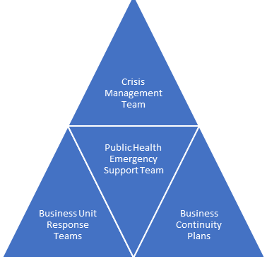
    - Continuing construction activities as directed by governing officials
Pandemic Committee & Aux. Committee
Human Resources
Regional Managers
Corporate Response Team
    - Office and project closures as per plan
    - Office and project re-openings
    - Social media releases
    - Media releases
    - Contract disputes

Pandemic Committees (PC)
The Pandemic Committees (PC) provides support and recommendations to the Corporate Response Team during a Pandemic. During the current Pandemic crisis, the PC will:
    - Meet daily or as agreed to strategize on vital health and safety steps
    - Make recommendations to the Corporate Response Team
    - Research reliable documents to ensure employees are accurately informed
    - Make available an email address for employees to send their questions/concerns
    - Produce and maintain a specific website

Monitoring External Communications
The PC will actively monitor the following information sources to identify any emerging public health issues including current Pandemic details:
      - World Health Organization (www.who.int)
      - Centre for Disease Control (http://www.cdc.gov/)
      - Public Health Agency of Canada (www.phac-aspc.gc.ca)
      - Local and provincial public health agencies

The PC will maintain contact with appropriate representatives from the various business units during the Pandemic.

Communications

Senior Management Communications
Senior management will on a regular basis, communicate what steps are being taken to ensure the health and safety all office and project teams is maintained. Updates will include important information from the Federal and Provincial government and Maple Reinders’ initiatives.

Pandemic Alerts
The PC will work with the CRT to ensure that appropriate Pandemic alert information is provided in a timely manner during a public health emergency. This will include sharing external and internal alert conditions associated with the current Pandemic.

The CEO and COO will approve the Pandemic alert condition. Maple Reinders will follow alert condition levels similar to the World Health Organization as outlined below:

Phase | Description | Response
0 | No COVID-19 concerns | - Implement normal good health practices (washing hands frequently, common areas cleaned routinely, hand sanitizer available in public areas, etc.)
1 | News of a specific potential Pandemic threat is circulated by Health authorities (the World Health Organization (WHO), Public Health Agency of Canada or the Centers for Disease Control (CDC)) with reports of human cases outside of countries of operation. | - Monitor disease progress  - Review the current Pandemic Response Plan  - Provide generic disease information to employees as deemed appropriate
2 | News of a specific potential Pandemic threat is circulated by health authorities with reports of human cases within countries of operation. | - Continue to monitor disease progress  - Review the current Pandemic Response Plan  - Begin non-invasive mitigation measures (wash hands more frequently, distribute hand sanitizer, clean common rooms more frequently, etc.)
3 | Health Authorities report that a Pandemic is present within the country of operation, but few reported cases are present in the Region/area of operation. | - Continue to monitor disease progress  - Consider enacting the company’s Pandemic Response Plan and appropriate regional response  - Consider invasive mitigation measures
4 | Health Authorities report that a Pandemic or epidemic disease is present within the region/area of operation. | - Enact Pandemic Response Plan and appropriate regional response  - Begin invasive mitigation measures (limit face-to-face meetings; limit travel, etc.)
5 | Cases have been confirmed within  Canada. | - Implement aggressive mitigation measures (exercise work from home plans, reduce human interfaces, etc.)
6 | Widespread health impacts to  Canadian Provinces | - Continue to manage event using the Pandemic Response Plan and appropriate
Please refer to Appendix 3 for more information on the current Pandemic.

Current Pandemic (COVID-19) Information
Historically, influenzas such as COVID-19 have had significant worldwide impacts. Five influenzas have occurred in the past century:
  - 1918 Spanish influenza
  - 1957 Asian influenza
  - 1968 Hong Kong influenza
  - 2003 SARS
  - 2009 H1N1 influenza

COVID-19 outbreaks occurred following predicable seasonal patterns and some immunity is built up from previous flu-type exposures. All age groups are at risk of serious complications from COVID-19.
However serious morbidity and mortality occurs almost exclusively in those with chronic underlying illness and the elderly.

Prevention during the current Pandemic (COVID-19)
The keys to preventing the current Pandemic outbreak are:
  - Comply with Provincial and Federal legislation
  - Complete daily health screening
  - Maintain proper social/physical distance from others
  - Face covers (how to use and care for your face cover)
  - Hand washing
  - Isolation as directed during illness

Comply with Provincial and Federal legislation
During the COVID-19 Pandemic, the government will institute and update requirements for everyone to follow such as but not limited to; where face covers must be worn, how many people can congregate and where, the number of people allowed in Social Circles/Cohort Groups and how different type of establishments can operate. Maple Reinders will follow these requirements and ensure they are enforced within our offices and on our projects.

Complete Daily Health Screening

Prior to entering a project or accessing an office past the reception area, every person is required to complete a daily screening process. Depending on the smart device an individual may or may not have, this procedure may differ.

iPhone users:

A QR code will be provide which will guide an individual to a Screening Survey consisting of three questions. All questions must be answered honestly to ensure the COVID-19 virus does not enter a project or office.

Once complete, the results must be shown upon entry to a project or office.

Android users:

Under the posted QR code, a Screening Survey link will be available. The Screening Survey consists of three questions which must be answered honestly to ensure the COVID-19 virus does not enter a project or office.

Once complete, the results must be shown upon entry to a project or office.

There are also QR Code reader Apps free from the Google store that can be utilized.

For individuals who do not own a smart phone, the current Screening Questionnaire (Appendix 9a, 9b or 9c) or equivalent must be completed daily.

Appendix 9d is a combination of a site/office sign-in as well as a condensed screening questionnaire.

Maintain proper social/physical distance from others
One of the most proven ways to prevent the spread of COVID-19 is to maintain a personal bubble of two metres. Air born respiratory droplets are the main source of transfer and by maintaining your personal bubble, you can greatly minimize the threat of contracting the virus. If there is no way to avoid maintaining your bubble, be sure to properly wear a face covering and keep in-close meetings brief.
Strategies for the worksites include:
  - Follow governing directives
  - Keep gatherings to the recommended number
  - Reduce face-to-face meetings, increasing the use of telephone and video conferences, and increase reliance on the electronic exchange of information
  - Minimize meeting times and meeting in large rooms, reducing contact
  - Whenever possible, physical contact with co-workers should be minimized i.e. avoid hand shaking, avoid lunch/break rooms
  - The use of shared workstations should be minimized or increased cleaning between use should occur
  - Flexible work hours, staggered shift changes, staggered lunch hours

Precautions for meal and break periods
There is an increased risk of spreading COVID-19 when workers are:
- close together
- in crowded places
- in closed spaces
- exposed for a longer time
- forcefully exhaling
These factors are important to address during break times and working hours. Make sure that shared spaces for eating, taking breaks are well-ventilated and set up to allow workers to maintain physical distance. Some actions that can be taken include:
- position tables, chairs and other furniture in meal and break rooms to help workers keep at least two metres of distance from each other
- remove furniture from break spaces that would lead to overcrowding if used
- provide more locations for eating and taking breaks
- provide visual markings to support physical distancing and control the flow of people (see appendix 13)
- make sure HVAC systems are properly maintained
- choose spaces with windows that open and keep them open as much as possible
- use any outdoor spaces available to you
Review these important items with your workers through ToolBox Talks and/or Monthly Safety Meetings.

Face covers - Requirements on when and how to use
When to use: Until further notice, face covering use will be required in all indoor work settings, except when alone in a workspace or an appropriate barrier is in place. This includes:
  - Project offices
- Company vehicles and personal vehicles when being used for business operations when more than one person is present
- While attending in-person meetings (i.e.: boardrooms)
- Anytime you leave your desk, cubicle or barrier/partition, for example:
  - When in the washroom
  - Getting a coffee
  - Heating up you your lunch
  - Moving in a hallway
*Mask use for areas under constructions are only mandatory when social/physical distancing is unavoidable or site-specific rules apply*

How to use: How to put on a non-medical mask or face covering
- Ensure the face covering is clean and dry.
- Wash your hands with warm water and soap for at least 20 seconds before touching the mask. If none is available, use hand sanitizer containing at least 60% alcohol
- Ensure your hair is away from your face.
- Place the face covering over your nose and mouth and secure to your head or ears with its ties or elastics. Adjust if needed to ensure nose and mouth are fully covered
- The mask should fit snugly to the cheeks and there should not be any gaps.
- Wash your hands or use alcohol-based hand sanitizer after adjusting your mask.
While wearing a non-medical mask or face covering, it is important to avoid touching your face. If you do touch your mask or face, you should immediately wash your hands with warm water and soap for at least 20 seconds, or use a hand sanitizer containing at least 60% alcohol.
How to remove a non-medical mask or face covering
- Wash your hands with warm water and soap for at least 20 seconds. If none is available, use hand sanitizer containing at least 60% alcohol
- Remove the face covering by un-tying it or removing the loops from your ears. Avoid touching the front of the mask when removing it.
- Store the face covering in a paper bag, envelope, or something that does not retain moisture if you will be wearing it again.
- After removing the face covering, wash your hands or use hand sanitizer.

Cleaning and disposing of non-medical masks and face coverings
Cloth masks or face coverings should be changed and cleaned if they become damp or soiled. You can wash your cloth mask by:
- putting it directly into the washing machine, using a hot cycle, and then dry thoroughly
- washing it thoroughly by hand if a washing machine is not available, using soap and warm/hot water, allow it to dry completely before wearing it again
Non-medical masks that cannot be washed should be disposed of properly in a lined garbage bin, and replaced as soon as they get damp, soiled or crumpled. Do not leave discarded masks in shopping carts or on the ground where other people may come into contact with them. It is important to remember the following when using non-medical masks and face coverings:
- masks with an exhalation valve do not protect others.
- never share your non-medical mask or face covering with someone else.
- do not handle a non-medical mask or face covering belonging to someone else.
- do not allow other people to handle or touch your non-medical mask or face covering.
Do's
Do wear a non-medical mask or face covering to protect yourself and others.
- Do ensure the mask is made of at least 3 layers, including 2 layers of tightly woven fabric, with a filter or filter fabric between layers.
- Do inspect the mask for tears or holes.
- Do ensure the mask or face covering is clean and dry.
- Do wash your hands or use alcohol-based hand sanitizer before and after touching the mask or face covering.
- Do use the ear loops or ties to put on and remove the mask.
- Do ensure your nose and mouth are fully covered.
- Do replace and launder your mask whenever it becomes damp or dirty.
- Do wash your mask with hot, soapy water and let it dry completely before wearing it again.
- Do store re-usable masks in a clean paper bag until you wear it again.
- Do discard masks that cannot be washed in a plastic lined garbage bin after use.

Don'ts
- Don't wear masks with exhalation valves or vents.
- Don't wear a loose mask.
- Don't touch the mask while wearing it.
- Don't remove the mask to talk to someone.
- Don't hang mask from your neck or ears.
- Don't share your mask.
- Don't leave your used mask within the reach of others.
- Don't reuse masks that are damp, dirty or damaged.
Remember, wearing a non-medical mask or face covering alone will not prevent the spread of COVID-19. Stay at home if you're sick, wash your hands often and practice physical distancing.

e) Hand Washing

Thorough hand washing (with warm water and soap, alcohol-based hand rub, or antiseptic hand wash) is one of the most effective measure to reducing the spread of the current Pandemic. Proper steps for hand washing include:

Wet your hands and apply enough liquid soap to create a good lather. The temperature of the water should be between 35ºC and 45ºC.

Rub your hands palm to palm in circular motions. Rotate clockwise and anticlockwise.
- Rub the Back of Hands
- Interlink Your Fingers
- Cup Your Fingers
- Clean the Thumbs
- Rub Palms with Your Fingers

All Maple Reinders’ projects and office will have running water to ensure proper hand washing can be done.
Waterless alcohol-based hand sanitizers (with a minimum 60% alcohol solution) can be used as an alternative to hand washing and are useful when sinks or warm running water is limited.

Containment Activities

Cleaning
During the current Pandemic, office and project cleanings will be reviewed and should include:
  - Develop cleaning checklists to ensure areas are not missed and regular cleanings are measured
  - Cleaning checks are to be scheduled
  - Designated personnel or cleaning companies are to be assigned for the cleanings
  - Steps to limit equipment sharing must be developed and implemented
  - Cleaning schedules must be implemented if equipment sharing is unavoidable

Employees are expected to ensure their personal workspace is properly sanitized during normal operations as well as Pandemic times.
Appendix 7 includes a summary of effective cleaning solutions.

b) Offsite Work Capabilities
Telecommuting, working at home, and the use of offsite locations are valuable tools that Maple Reinders can use to contain the spread of illness. Working remotely is a viable option and should be reviewed with an employees’ manager. Managers are strongly encouraged to develop rotating in-office work schedules to reduce the number of employees in a workplace at one time in work environments with high capacities and where distancing cannot be maintained or workspaces are not adequately separated by barriers.
c) Management of Cases at Work
If an employee feels ill, or if someone observes that a person is exhibiting symptoms associated with the COVID-19 virus, the employee’s supervisor should be contacted and the employee is instructed to leave site and seek medical attention. The supervisor should then discuss this situation with the site management team and the Pandemic Committee. The Contact Care Table (Appendix 12) can be used to aid in the reactionary steps.
If there is a confirmed case, the following steps are to be taken:
- Use our Confirmed COVID-19 Case – Response Flowcharts
- Stop work on site or designated areas
- Make contact your Division Manager and a member/s of the Pandemic Committee
- Inform workers and subs of the confirmed case
- Using the provided definitions, determine who has had Close Contact or Secondary Contact with the confirmed case at the project, in a vehicle or in a hotel room
- Conduct an investigation
- Determine what areas will need to be deep cleaned. Areas may include but are not limited to: site trailers, C-cans, washrooms, vehicles, tools, equipment etc.

d) Travel
As of November 23rd and until further notice all non-essential interprovincial travel will cease. Essential travel must be pre-approved by the COO.
The reduction of Zone-to-Zone travel is strongly recommended for employees in Ontario.
https://files.ontario.ca/moh-covid-19-response-framework-keeping-ontario-safe-and-open-en-2020-11-13.pdf

7. Treatment & Medical Assistance

Treatment

All treatment of cases will be done through the direction of employees’ family Dr.

Medical Assistance
Employees currently have access to health care programs through government, benefit programs, social programs and employee assistance programs. Maple Reinders management will continue to regularly review these programs to ensure they are appropriate for employees’ needs.

During the Pandemic emergency, the existing benefit, health services, and employee assistance programs, would be reviewed by Maple Reinders management to determine if supplement assistance would be required. This could include:
  - Special policies for extended leave
  - Additional employee compensation and/or sick leave
  - Additional support for mental health care

8. Preparedness

Employee Awareness Training
As part of the PRP, awareness sessions will be provided through Orientations, ToolBox Talks and general broadcasting. Steps, such as staggering meeting times and changing meeting locations will occur ensure these sessions are conducted as per the guidelines.

Personal Planning Information for Employees
The CRT, PC and RMs will work with employees to assist with additional planning.

9. Return to Work (Exposure, defined as being in Close Contact with confirmed case.)

- If under self-Isolation due to travelling outside the country or you have had Close Contact with someone who has COVID-19, you are able to return to work if:
- You have received a Negative COVID-19 test result;
- You have isolated for 14 days;
- You are symptom free;
- You can pass the provincial self-assessment and/or the Maple Reinders’ screening process and
- Cleared by your local Public Health Unit

- If under self-Isolation due to having symptoms of COVID-19 and you do NOT get tested, you are able to return to work if:
- You have isolated for 10 days;
- You are symptom free;
- You can pass the provincial self-assessment and/or the Maple Reinders’ screening process and
- Your supervisor is aware of your return date

- If under self-Isolation due to having symptoms of COVID-19 and you have received a negative test result for COVID-19, you are able to return to work if:
  - You are symptom free;
  - You can pass the provincial self-assessment and/or the Maple Reinders’ screening process and
  - Your supervisor is aware of your return date

- If under self-Isolation due to having tested positive for COVID-19, you are able to return to work if:
- You have isolated a minimum of 10 days after receiving the test result;
- You have completed all medically prescribed instructions;
- You have received clearance from your local Public Health Unit;
- You are symptom free;
- You can pass the provincial self-assessment and the Maple Reinders’ screening process and
- Your supervisor is aware of your return date
Self-Assessment Tool links can be found on the Maple Reinders’ COVID19 website.
    - First Aid Procedure
RESPONSIBILITY
First Aid Attendants

TOOLS AND EQUIPMENT REQUIRED
- Face cover
- Hand sanitizer
- Waste bags
- Goggles
- Approved respirator or equivalent
- Disposable non-latex gloves
- CPR barrier/s

PROCEDURE
- Assess patient walk in or onsite response
  - When a patient arrives at first aid station or you arrive on the scene, maintain physical/social distance if possible or wear a face cover and communicate to the patient that you are qualified to assess/assist them, you have been fully screened and acquire consent to assist.
  - Ensure EMS has been called if needed.
  - Remind others who may gather at the scene to maintain physical/social distancing, wear a face cover or fully disperse.
  - Perform hand hygiene (wash hands with soap & water or rinse thoroughly with hand sanitizer) and use the following additional PPE prior to treatment (non-latex gloves, approved face mask or respirator and face shield (if available)).
  - If you need assistance, ensure the above steps are taken before your assistant/s proceeds.
  - Only handle the equipment required during the treatment to reduce contamination.
  - Provide first aid within the level of your training. Once EMS arrives follow directions given.

- Hygiene and disposal
This process is to be followed by every First Aid Attendant each time they render first aid treatment during a walk in or onsite response.

  - The entire first aid room and all equipment touched are sanitized. All potentially contaminated equipment, first aid room and PPE must be cleaned and disinfected before it is used, or access is allowed.
  - Remove all PPE (non-latex gloves, mask) carefully to ensure no cross contamination and dispose of it along with any potentially contaminated wipes, rags, first aid disposable materials.
Wash hands thoroughly before doing any paperwork.

Projects & Spare Truck Cleaning Requirements

(APPEN 7 & 10)
Our construction sites operating during the Covid-19 Pandemic need to ensure they are protecting their workforce and minimizing the risk of spread of infection. This guidance is intended to introduce consistent measures on all active projects.

The following shall be in place on each site:
- A Site Sanitation Checklist and schedule for cleanings
- Sufficient toilet facilities with soap/sanitizer dispensers
- Hand washing facilities with soap/sanitizer and paper towels
- Sufficient cleaning products for daily usage

Cleaning procedures will be in implemented on each project, with minimum of daily cleaning / wipe downs particularly in communal areas and at touch points including:
- Toilet and washing facilities – ensuring dispensers stocked
- Door handles and push plates
- Handrails on staircases and corridors
- Elevator and hoist controls where shared use
- Machinery and equipment controls where shared use
- Shared keyboards, computer or phones
- Shared site radios o Photocopiers and other shared office equipment with touch points (eg coffee makers, microwaves etc)
- Common Areas – desks/meeting tables/sign in points

Trash collection and storage points will be increased and emptied regularly and at the end of each day or as needed.

Efforts will be taken to reduce the need for the use of spare company trucks throughout the Pandemic. However, if the need is unavoidable, proper cleaning procedures will be completed to ensure the vehicle cab is properly sanitized for the next user. The Spare Vehicle Inspection Checklist will be completed (Appendix 11). Cleaning supplies such as wipes and hand sanitizer will be kept in the vehicle for immediate use.

APPENDIX 1 – REFERENCE MATERIAL SUMMARY

The following key reference materials were reviewed in the development of the PRP:

External Resources:
  - Alberta, British Columbia, and Ontario Self-Assessment Tools
  - World Health Organization
  - Public Health Agency of Canada & Public Safety and Emergency Preparedness Canada Working Group on COVID-19 Influenza Planning Discussions Notes
  - Public Safety and Emergency Preparedness Canada
  - Health Canada
  - New Zealand Ministry of Economic Development
  - Canadian Electrical Associations – Preparedness and Response, COVID-19 Influenza
  - The Economic Impact of an COVID-19 Influenza – Department of Finance Economic analysis and forecasting division – January 24, 2006 Presentation
  - Canadian Manufacturers & Exported COVID-19 Influenza: Continuity Planning Guide for Canadian Businesses

APPENDIX 2 – COVID-19 WARNING NOTICE

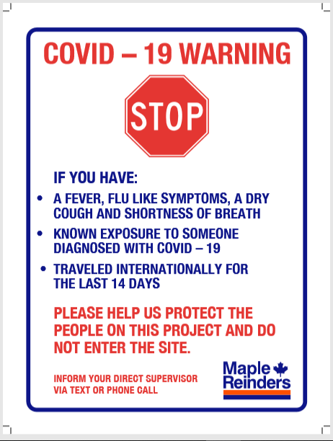

APPENDIX 3 – COVID-19 INFORMATION SHEET

DIFFERENCE BETWEEN COVID-19 AND A COMMON COLD
SYMPTOM | COVID-19 | Common Cold
Fever | Usual, sudden onset 38C – 40C and lasts 3 – 4 days | Rare
Headache | Usual but can be severe | Rare
Aches and pains | Usual but can be severe | Rare
Fatigue and weakness | Usual and can last 2 – 3 weeks or more after acute illness | Sometimes, but mild
Debilitating fatigue | Usual, early onset can be severe | Rare
Nausea, vomiting, diarrhea | In children <5 years old | Rare
Watering of the eyes | Rare | Usual
Runny, stuffy nose | Rare | Usual
Sneezing | Rare in early stages | Usual
Sore throat | Usual | Usual
Chest discomfort/Cough | Usual and can be severe | Sometimes, but mild to moderate
Complications | Respiratory failure; can worsen a current chronic condition; can be life threatening | Congestion or ear-ache
Fatalities | Well recognized | Not reported
Prevention | frequent hand-washing, cover your cough, maintain two metres from other individuals, sanitize office and work areas daily | Frequent hand-washing, cover your cough

APPENDIX 4a – Corporate Response Team

Member | Job title |  |  | Location
Harold Reinders | CEO |  |  | Mississauga
Jeremy Olthuis | COO |  |  | Edmonton
Paul Gibson | VP HR |  |  | Mississauga
Chris Moran | General Council |  |  | Mississauga

APPENDIX 4b –Pandemic Committee

Member | Job title | Cell Phone | Email | Location
Craig Sparks | H&S Manager | 416-459-7344 |  | Mississauga
Steve Van Hoffen | Director of Finance | 905-745-5240 |  | Mississauga
Kevin Dreyer | I.T. Director | 416-4597930 |  | Mississauga
Robin Sodia | HR Manager | 416-948-1505 |  | Mississauga
Jonas Van Gin Hoven | RM | 780-289-7461 |  | Edmonton
Glen Spalding | RM | 250-470-8400 |  | Kelowna
Natasha Braganza | H&S Admin | 416-899-3874 |  | Mississauga

APPENDIX 5 – COVID-19 TRACKING
General Instructions:

Each Regional H&S Coordinator will complete a weekly tracking sheet and report the HR Manager.

APPENDIX 6 - SUSPECTED COVID-19 HEALTH CASE AT WORK

General Instructions:
In order to ensure that an employee’s private and medical information is properly managed and protected, all Regional Managers are asked consult with HR and to adhere to the following protocols:

- All medical information is personal information that must be held confidential. As such, electronic information containing such medical information must be kept in a protected location where access is limited and secure from viewing by other employees.

- If it is necessary to raise an issue relating to an employee’s medical information for business purposes (i.e. return to work decisions, coverage, etc.) any documents and e-mails must be marked “Confidential” and should be sent ONLY to those necessary to make a decision. Limit the amount of personal information (i.e. information that can identify a person such as their name, medical information, address, date of birth, etc.) to only that which is necessary in such communications.

- If it is necessary to advise groups of co-workers who have been in contact with an employee who is away for medical reasons for the purpose of maintaining public health, convey the information without disclosing personal information of the employee who is away. Use generic terms whenever possible, like “an individual in your work area” or “an individual on your floor”.

- Aggregating any medical information for trending and reporting purposes is fine, as long as individual employees cannot be identified from the aggregated material.

- All documentation should be placed and kept in a protected/secure location (electronically or hardcopy) in accordance with document retention requirements. The Regional Manager shall ensure that records of any confidential information beyond the time period that the information is required for business purposes, is disposed of in a secure manner.

APPENDIX 7 – PERSONAL COVID-19 PLANNING

Personal Health

  - Eat, rest well and exercise in moderation
  - Wash your hands frequently with warm water and soap
  - Cover your nose and mouth when coughing or sneezing
  - Minimize visitors at home
  - Check up on friends and family who live alone
  - Teach your children to wash hands frequently with soap and water
  - Stay informed – watch for updates from public health providers
  - Get the COVID-19 vaccine when available

Stay away from crowds

  - Stock up (not panic buy) on basic items (food, water, medical supplies)
  - Shop at smaller stores with smaller line-ups
  - Shop at off peak hours
  - Consider pre-ordering groceries and then just pick up or have delivered
  - Pay bills electronically
  - Postpone family gatherings, outings, trips

Stay healthy at work and at home
  - Maintain contact with colleagues who may be working remotely
  - Use Teams or Zoom to talk face to face (virtually)
  - Continue to look after your physical and mental condition
  - Maintain a healthy diet

APPENDIX 8 –COVID-19 Active Screening Sign-In Sheet

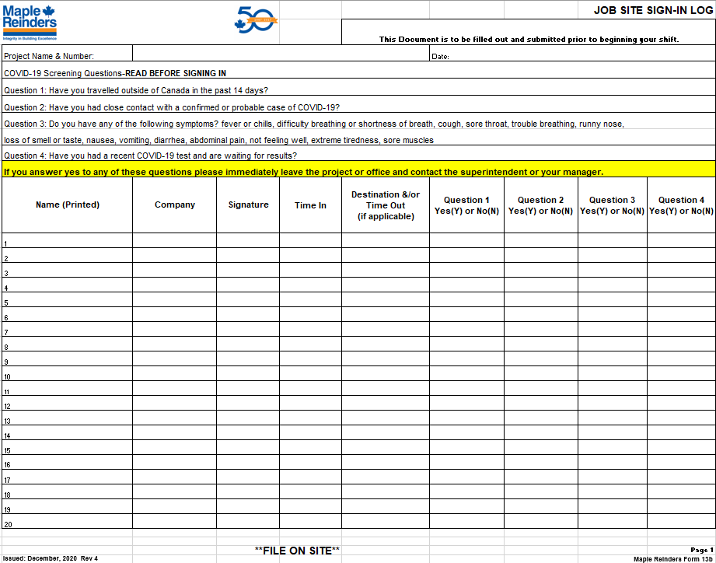

APPENDIX 9–COVID-19 Site Sanitation Checklist

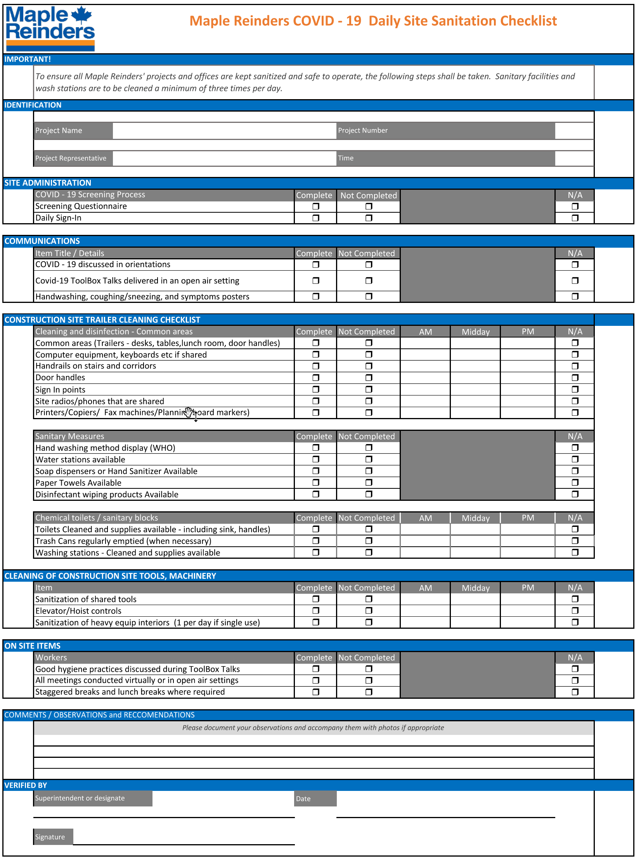

APPENDIX 10–COVID-19 Spare Vehicle Inspection Checklist

Vehicle Information
Vehicle: |  |  |  |  | Date Out: |  |  |  |  | DATE In:
License Plate: |  |  |  | Prov: |  |  | Km Out |  |  |  | Km In
Driver:
Checklist
Prior to Starting
Windshield (good condition?) | Yes | No
Washer fluid level (adequate for conditions?) | Yes | No
Tires & wheels (low, missing lug nuts?) | Good | Needs Repair
Leaks (visible leakage under vehicle?) | None | Needs Repair
Body condition (dings & scratches?) Indicate on reverse | Yes | Damage Noted
COVID19-Have you sanitized high touch areas in the vehicle? (Steering wheel, radio, arm rests, door handles etc) | Yes | No
COVID19-Car pooling is not allowed in this vehicle.
After Starting
Check engine light (did it come on?) | No | Yes
Tire pressure confirmation (did it give a warning?) | No | Yes
Headlights (do they all work? Hi beams?) | Yes | No
Turn signals (do they all work?) | Yes | No
Brake lights (do they work?) | Yes | No
Upon Return
Vehicle cleanliness (appropriate condition?) | Yes | No
Fuel tank at least half full | Yes | No
Deficiencies reported | Yes | No
Repairs / maintenance performed? | Yes | No
Receipts attached? | Yes | No
Fleet Card & keys returned? | Yes | No
COVID19-Have you sanitized high-touch areas of the vehicle? (steering wheel, radio, arm rests, door handles etc) | Yes | No
COVID19-Have you left enough cleaning produces in this vehicle for the next person? | Yes | No
Notes
SIGNATURE:

APPENDIX 11–COVID-19 Confirmed and Non-Confirmed Case Response Flowcharts

*All flowcharts in their entirety can be found on the website*
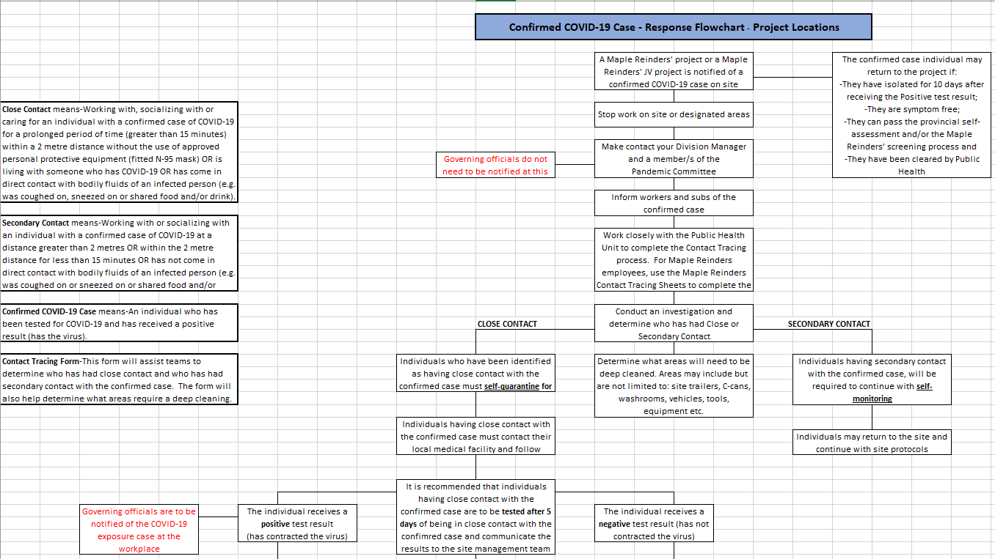

APPENDIX 12-COVID-19
How to create a safe Social Circle/Bubble/Cohort Group

Safe Social Circle/Bubble/Cohort Group

Ontario, BC and Alberta

To all Maple Reinders employees and partners, as the second wave surges in all Provinces and restrictions on Social Circles, Bubbles and Cohort Groups continuously change, the Pandemic Committee asks you to keep yourself up to date and informed on regional restriction.The only way we get through this is if everyone does their part.

https://news.ontario.ca/en/release/58449/ontario-limits-the-size-of-unmonitored-and-private-social-gatherings-across-entire-province#resources

http://www.bccdc.ca/health-info/diseases-conditions/covid-19/social-interactions

https://www.alberta.ca/restrictions-on-gatherings.aspx
APPENDIX 13-COVID-19 Lunchroom and Breakroom Capacity Signs
(Please contact Laura Di Paolo)

