COVID-19
PANDEMIC RESPONSE & SAFETY PLAN

Version  Number | Date | Document  Owner | Department | Approved By | Latest Revision Made
19 | 08-25-21 | Craig Sparks | Health & Safety | Pandemic Committee | Revised:  - Commitment  - Actions to take due to exposure  - Exposure Flowchart
 |  |  |  |  | All changes are highlighted in YELLOW

*Maple Reinders is committed to the safety of our workers including their physical, psychological, and social well-being. It is our belief that every worker is entitled to work in a safe and healthy environment. Collaboratively, Maple Reinders and our workers have the duty to take every reasonable precaution to ensure each worker and fellow worker is kept safe and free of hazards. Throughout this Provincial Pandemic Response and Safety Plan, the word “Recommended” means the following: Maple Reinders and your provincial authorities feel the suggested course of action or protective device is the safest option for you, your family, and your workplace. However, the suggested course of action is a personal choice, not a mandate.*

Table of Contents
1. Introduction 3
a) Commitment 3
b) Objective 3
c) Plan Integration 3
d) Activation 3
2. Organization & Responsibilities 4
Overall Structure 4
Corporate Response Team 4
Pandemic Committee 5
3. Monitoring External Communications 5
4. Communications 5
a) Senior Management Communications 5
b) Pandemic Alerts 5
c) Current Pandemic (COVID-19) Information 6
5. Prevention 6
a) Comply with Provincial and Federal Legislation 6
b) Complete Daily Health Screening 6
c) Maintain Proper Social/Physical Distance from Others 6
d) Precautions for Meal and Break Periods 7
e) Face Covers – Requirements on when and how to use 7-8
f) Maintaining Personal Hygiene 9
6. Containment Activities 10
a) Cleaning 10
b) Offsite Work Capabilities 10
c) Management of Cases at Work 10
d) Travel 10
7. Treatment & Medical Assistance 11
a) Treatment 11
b) Medical Assisstance 11
8. Preparedness 11
a) Employee Awareness Training 11
b) Personal Planning Information for Employees 11
9. Actions to Take Due to Exposure 11-12
10. First Aid Procedure 12-13
11. Projects and Spare Vehicle Cleaning Requirements (APPENDIX 7 & 10) 13
12. Vaccinations 14

APPENDIX 1a&b – Corporate Response Team & Pandemic Committee 14
APPENDIX 2 – COVID-19 Signage 15
APPENDIX 3 – Personal COVID-19 Planning 16
APPENDIX 4 – COVID-19 Active Screening Sign-In Sheet 17
APPENDIX 5 – COVID-19 Site Sanitation Checklist 18
APPENDIX 6 – COVID-19 Spare Vehicle Inspection Checklist 19
APPENDIX 7 – COVID-19 Exposure Flowchart 20
APPENDIX 8 – COVID-19 Reopening Plans………..…………….…………………………...20

Introduction

Commitment

Maple Reinders is committed to the safety of our workers including their physical, psychological, and social well-being. It is our belief that every worker is entitled to work in a safe and healthy environment. Collaboratively, Maple Reinders and our workers have the duty to take every reasonable precaution to ensure each worker and fellow worker is kept safe and free of hazards.

Objective

The objective of the Maple Reinders Pandemic Response and Safety Plan (PRSP) is to manage the impact of a Pandemic on employees and business activities using two main strategies:

  - Protect our staff, guests, and the public
  - Containment of the disease by reducing spread within the business

Plan Integration

The PRSP responsibilities, preparedness activities and response activities are integrated with the following plans and processes:

  - HSE Manual
  - Project Emergency Response Plans
  - Crisis Management Plan

Whenever possible, the PRSP references support services and processes that already exist and identify activities and processes that need to be integrated across the company.

Activation

The activation of the Pandemic Response and Safety Plan consists of:

  - The activation of the Pandemic Committee and Pandemic Auxiliary Committee
  - Corporate Response Team
  - Consultation with businesses and functions on critical processes, impacts and priorities.

Organization & Responsibilities
The PRSP is maintained and updated by Maple Reinders’s management team with input and support from all departments as required. The following outlines key responsibilities by department or area as detailed in the PRSP:

  - Corporate Response Team is the lead for coordinating activities related to Public Health Emergencies.
  - Pandemic Committee is responsible for monitoring for health emergencies and making recommendations to the Corporate Response Team.
  - Regional management teams are responsible for communicating the plan to their teams.
  - Corporate Response Team maintains the response structures.

Overall Structure

Corporate Response Team (CRT)
The Corporate Response Team (CRT) is ultimately responsible for the steps taken during the current Pandemic. These decisions include but are not limited to:

    - Employee protection steps
- Continuing construction activities as directed by governing officials
    - Office and project closures as per plan
    - Office and project re-openings
    - Social media releases
    - Media releases
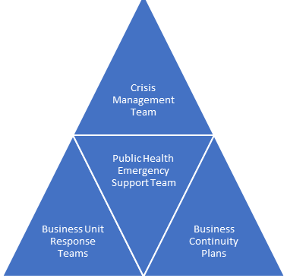
    - Contract disputes
Corporate Response Team
Human Resources
Pandemic Committee & Aux. Committee
Regional Managers

Pandemic Committees (PC)
The Pandemic Committees (PC) provides support and recommendations to the Corporate Response Team during a Pandemic. During the current Pandemic, the PC will:
    - Meet monthly or as agreed to strategize on vital health and safety steps
    - Make recommendations to the Corporate Response Team
    - Research reliable documents to ensure employees are accurately informed
    - Make available an email address for employees to send their questions/concerns
    - Produce and maintain a specific website

Monitoring External Communications
The PC will actively monitor the following information sources to identify any emerging public health issues including current Pandemic details:
      - World Health Organization (www.who.int)
      - Centre for Disease Control (http://www.cdc.gov/)
      - Public Health Agency of Canada (www.phac-aspc.gc.ca)
      - Local and provincial public health agencies

The PC will maintain contact with appropriate representatives from the various business units during the Pandemic.

Communications

Senior Management Communications
Senior management will on a regular basis or as needed, communicate what steps are being taken to ensure the health and safety for all office and project teams is maintained. Updates will include important information from the Federal and Provincial government and Maple Reinders’ initiatives.

Pandemic Alerts
The PC will work with the CRT to ensure that appropriate Pandemic alert information is provided in a timely manner during a public health emergency. This will include sharing external and internal alert conditions associated with the current Pandemic.

The CEO and COO will approve the Pandemic alert conditions. Maple Reinders will follow alert condition levels set by local Public Health Units.

Current Pandemic (COVID-19) Information
As the COVID-19 information continues to change, all Maple Reinders’ employees are encouraged to follow their local Public Health Unit recommendations and keep themselves educated on the current and ever-changing guidelines.

Prevention during the current Pandemic (COVID-19)

Comply with Provincial and Federal legislation
During the COVID-19 Pandemic, the government will institute and update requirements for everyone to follow such as but not limited to; face covers, how many people can congregate and where, the number of people allowed in Social Circles/Cohort Groups and how different type of establishments can operate. Maple Reinders will follow these requirements and ensure they are enforced within our offices and on our projects.

Complete daily health screening as required

Prior to entering a project or accessing an office past the reception area, every person is required to complete a daily screening process. Depending on the smart device, an individual may or may not have, this procedure may differ.

iPhone users:

A QR code will be provided at certain locations which will guide an individual to a Screening Survey consisting of symptom checks, travel, age, address, and exposure questions (subject to change). All questions must be answered honestly to ensure the COVID-19 virus does not enter a project or office.

Once complete, the results must be shown upon entry to a project or office.

Android users:

Under the posted QR code, a Screening Survey link will be available. The Screening Survey includes consistent symptom checks, travel, age, address, and exposure questions (subject to change) which must be answered honestly to ensure the COVID-19 virus does not enter a project or office.

Once complete, the results must be shown upon entry to a project or office.

There are also QR Code reader Apps free from the Google store that can be utilized.

For individuals who do not own a smart phone, the current Screening Questionnaire (Appendix 9a, 9b or 9c) or equivalent must be completed daily. *Appendix 9d is a combination of a site/office sign-in as well as a condensed screening questionnaire.*

Maintain proper social/physical distancing requirements
One of the most proven ways to prevent the spread of COVID-19 is to maintain a personal bubble of two meters. Air born respiratory droplets are the main source of transfer and by maintaining your personal bubble, you can greatly minimize the threat of contracting the virus. If there is no way to avoid maintaining your bubble, be sure to properly wear a face covering and keep in-close meetings brief.
Strategies for the worksites include:
  - Follow regional guidelines
  - Keep gatherings to the recommended number
  - Reduce face-to-face meetings, increasing the use of telephone and video conferences, and increase reliance on the electronic exchange of information
  - Minimize meeting times and meeting in large rooms, reducing contact
  - Whenever possible, physical contact with co-workers should be minimized i.e., avoid hand shaking, avoid lunch/break rooms
  - The use of shared workstations should be minimized or increased cleaning between use should occur
  - Flexible work hours, staggered shift changes, staggered lunch hours
  - Avoid carpooling

Precautions for meal and break periods
There is an increased risk of spreading COVID-19 when workers are:
- close together
- in crowded places
- in closed spaces
- exposed for a longer time
- forcefully exhaling
These factors are important to address during break times and working hours. Make sure that shared spaces for eating, taking breaks are well-ventilated and set up to allow workers to maintain physical distance. Some actions that can be taken include:
- position tables, chairs and other furniture in meal and break rooms to help workers keep at least two metres of distance from each other
- remove furniture from break spaces that would lead to overcrowding if used
- provide more locations for eating and taking breaks
- provide visual markings to support physical distancing and control the flow of people (see appendix 13)
- make sure HVAC systems are properly maintained
- choose spaces with windows that open and keep them open as much as possible
- use any outdoor spaces available to you
Review these important items with your workers through ToolBox Talks and/or Monthly Safety Meetings.

Face covers - Requirements on when and how to use
When to use: As we see each Province, Region and Municipality re-open, requirements will differ. Each Maple Reinders employee will be required to follow all government guidelines for the region you are in and may be travelling to. Face covers are to be worn when:
  - Regional guidelines instruct you to
  - You choose to for personal reasons
  - Required by a Client, Owner or Prime Contractor

How to use: How to put on a mask or face covering
- Ensure the face covering is clean and dry.
- Wash your hands with warm water and soap for at least 20 seconds before touching the mask. If none is available, use hand sanitizer containing at least 60% alcohol
- Ensure your hair is away from your face.
- Secure the face covering over your nose, mouth, and chin. Adjust if needed to ensure nose and mouth are fully covered
- The mask should fit snugly to the cheeks and there should not be any gaps.
- Wash your hands or use alcohol-based hand sanitizer after adjusting your mask.
While wearing a mask or face covering, it is important to avoid touching your face. If you do touch your mask or face, you should immediately wash your hands with warm water and soap for at least 20 seconds or use a hand sanitizer containing at least 60% alcohol.
How to remove a mask or face covering
- Wash your hands with warm water and soap for at least 20 seconds. If none is available, use hand sanitizer containing at least 60% alcohol.
- Remove the face covering by un-tying it or removing the loops from your ears or strap. Avoid touching the front of the mask when removing it.
- Store the face covering in a paper bag, envelope, or something that does not retain moisture if you will be wearing it again.
- After removing the face covering, wash your hands or use hand sanitizer.
Cleaning and disposing of masks and face coverings
Masks or face coverings should be changed and cleaned if they become damp or soiled. You can wash your cloth mask by:
- putting it directly into the washing machine, using a hot cycle, and then dry thoroughly.
- washing it thoroughly by hand if a washing machine is not available, using soap and warm/hot water, allow it to dry completely before wearing it again.
Masks that cannot be washed should be disposed of properly. Recycle them if possible. Do not leave discarded masks in shopping carts or on the ground where other people may come into contact with them. It is important to remember the following when using masks and face coverings:
- masks with an exhalation valve do not protect others.
- never share your mask or face covering with someone else.
- do not handle a mask or face covering belonging to someone else.
- do not allow other people to handle or touch your non-medical mask or face covering.

Do's
- Do wear a face covering as prescribed by your local legislation.
- Do ensure the mask is made of at least 3 layers, including 2 layers of tightly woven fabric, with a filter or filter fabric between layers.
- Do inspect the mask for tears or holes.
- Do ensure the mask or face covering is clean and dry.
- Do wash your hands or use alcohol-based hand sanitizer before and after touching the mask or face covering.
- Do use the ear loops or ties to put on and remove the mask.
- Do ensure your nose and mouth are fully covered.
- Do replace and launder your mask whenever it becomes damp or dirty.
- Do wash your mask with hot, soapy water and let it dry completely before wearing it again.
- Do store re-usable masks in a clean paper bag until you wear it again.
- Do discard masks that cannot be washed in a plastic lined garbage bin after use.

Don'ts
- Don't wear masks with exhalation valves or vents.
- Don't wear a loose mask.
- Don't touch the mask while wearing it.
- Don't remove the mask to talk to someone.
- Don't hang mask from your neck or ears.
- Don't share your mask.
- Don't leave your used mask within the reach of others.
- Don't reuse masks that are damp, dirty, or damaged.
Remember, even though mask restrictions are becoming less stringent. Some individuals will continue to wear them as a personal preference.

f) Maintaining personal hygiene

Thorough hand washing (with warm water and soap, alcohol-based hand rub, or antiseptic hand wash) is one of the most effective measure to reducing the spread of COVID-19. Proper steps for hand washing include:

Wet your hands and apply enough liquid soap to create a good lather. The temperature of the water should be between 35ºC and 45ºC.

Rub your hands palm to palm in circular motions. Rotate clockwise and anticlockwise.
- Rub the Back of Hands
- Interlink Your Fingers
- Cup Your Fingers
- Clean the Thumbs
- Rub Palms with Your Fingers
All Maple Reinders’ projects and offices will endeavor to provide running water to ensure proper hand washing can be done.
Waterless alcohol-based hand sanitizers (with a minimum 60% alcohol solution) can be used as an alternative to hand washing and are useful when sinks or warm running water is limited.

Containment Activities

Cleaning
During the current Pandemic, office and project cleanings will be reviewed and should include:
  - Develop cleaning checklists to ensure areas are not missed and regular cleanings are measured
  - Cleaning checks are to be scheduled
  - Designated personnel or cleaning companies are to be assigned for the cleanings
  - Steps to limit equipment sharing must be developed and implemented
  - Cleaning schedules must be implemented if equipment sharing is unavoidable

Employees are expected to ensure their personal workspace is properly sanitized during normal operations as well as Pandemic times.
Appendix 7 includes a summary of effective cleaning solutions.

b) Offsite Work Capabilities
Telecommuting, working at home, and the use of offsite locations are valuable tools that Maple Reinders can use to contain the spread of illness. Working remotely is a viable option and should be reviewed with an employees’ manager. Managers are encouraged to develop rotating in-office work schedules to reduce the number of employees in work environments with high capacities and where distancing cannot be maintained, or workspaces are not adequately separated by barriers. Follow local Public Health guidelines.
c) Management of Cases at Work
If an employee feels ill, or if someone observes that a person is exhibiting symptoms associated with the COVID-19 virus, the employee’s supervisor should be immediately contacted, and the employee is instructed to leave site or office and seek medical attention. The supervisor should then discuss this situation with the site management team and the Pandemic Committee. Local guidelines/flowcharts and Public Health Units can be used to determine if isolation, quarantine, or monitoring is needed. In-house contact tracing will be completed by the project or office personnel with the guidance of the Pandemic Committee. Check with Public Health Units when contact tracing is needed for subcontractors.

d) Travel
Follow all travel requirements as per your local reopening guidelines.

7. Treatment & Medical Assistance

Treatment

All treatment of cases will be done through the direction of the employees’ family physician or Public Health authorities.

Medical Assistance
Employees currently have access to health care programs through government, benefit programs, social programs, and employee assistance programs. Maple Reinders management will continue to regularly review these programs to ensure they are appropriate for employees’ needs.

During a Pandemic emergency, the existing benefit, health services, and employee assistance programs, would be reviewed by Maple Reinders management to determine if supplemental assistance would be required. This could include:
  - Special policies for extended leave
  - Additional employee compensation and/or sick leave
  - Additional support for mental health care

8. Preparedness

Employee Awareness Training
As part of the PRSP, awareness sessions will be provided through Orientations, ToolBox Talks and general broadcasting. Steps, such as staggering meeting times and changing meeting locations will occur to ensure these sessions are conducted as per the guidelines.

Personal Planning Information for Employees
The CRT, PC and RMs will work with employees to assist with additional planning.

9. Actions to take due to exposure-Asymptomatic

(Exposure, defined as being in Close Contact with confirmed case.)

A vaccinated person who is asymptomatic
- If you have been exposed to COVID-19, and you have been fully vaccinated (meaning you have received your second dose prior to the 14 days before you were exposed) and are asymptomatic, you are not required to self-isolate and will need to self-monitor for symptoms for 10 days. If symptoms develop within the 10 days, self-isolate and call 811 to notify your Public Health Unit of your close contact and symptoms. Your household members are not required to self-isolate.

A vaccinated person who is symptomatic
- If you have been exposed to COVID-19, and you have been fully vaccinated (meaning you have received your second dose prior to the 14 days before you were exposed) and are symptomatic, you are required to self-isolate and must be tested immediately. If that test comes back positive, you must self-isolate for 10 days. If the test is negative, you can stop self-isolating once those symptoms have improved for at least one day, or two days for gastrointestinal symptoms. If your household members are vaccinated, they are not required to self-isolate. However, if they are not vaccinated, they are required to self-isolate until you receive a negative test result.

A non-vaccinated person
- If you have been exposed to COVID-19, and have not been vaccinated (meaning you have not received a second dose prior to the 14 days before you were exposed), you are required to self-isolate for 10 days and contact your local Public Health Unit (811) for further instructions. If a test is required and you receive a negative result, a second test is recommended on or after day seven of that self-isolation period. Regardless of a negative test result, you must self-isolate for the full 10 days. However, if you are symptomatic, your self-isolation may be extended until you see an improvement in you condition for 24 hours or 48 hours for gastrointestinal symptoms. Your household members should isolate during your self-isolation period unless for essential reasons such as work or school.

    - Actions to take due to exposure-Symptomatic
- If you have a symptom of COVID-19, you need to self-isolate right away and contact your local Public Health Unit (811) for further instructions. Immediately inform your direct supervisor of your condition and test result.
- If your test result is negative, continue to self-isolate until you feel better or for the amount of time Public Health has told you to self-isolate.
- If your test result is positive, self-isolate for 10 days from the day you noticed symptoms. If you do not feel better after the 10 days, you need to keep self-isolating until you feel better or for the amount of time Public Health has told you to self-isolate. If you feel worse during your self-isolation, contact your local Public Health Unit (811) or a health care provider for further instructions.

    - First Aid procedure
RESPONSIBILITY
First Aid Attendants

TOOLS AND EQUIPMENT REQUIRED

- Face cover
- Hand Sanitizer
- Waste bags
- Goggles/glasses
- Approved respirator or equivalent
- Disposable non-latex gloves

- CPR barrier/s

PROCEDURE

- Assess patient walk in or onsite response
  - When a patient arrives at first aid station or you arrive on the scene, maintain physical/social distance if possible or wear a face cover and communicate to the patient that you are qualified to assess/assist them, you have been fully screened and acquire consent to assist.
  - Ensure EMS has been called if needed.
  - Remind others who may gather at the scene to maintain physical/social distancing, wear a face cover, or fully disperse.
  - Perform hand hygiene (wash hands with soap & water or rinse thoroughly with hand sanitizer) and use the following additional PPE prior to treatment (non-latex gloves, approved face mask or respirator and face shield (if available)).
  - If you need assistance, ensure the above steps are taken before your assistant/s proceeds.
  - Only handle the equipment required during the treatment to reduce contamination.
  - Provide first aid within the level of your training. Once EMS arrives follow directions given.

- Hygiene and disposal
This process is to be followed by every First Aid Attendant each time they render first aid treatment during a walk in or onsite response.

  - The entire first aid room and all equipment touched are sanitized. All potentially contaminated equipment, first aid room and PPE must be cleaned and disinfected before it is used, or access is allowed.
  - Remove all PPE (non-latex gloves, mask) carefully to ensure no cross contamination and dispose of it along with any potentially contaminated wipes, rags, first aid disposable materials.

Projects & Spare Truck Cleaning Requirements

(APPEN 7 & 10)

Efforts will be taken to reduce the need for the use of spare company trucks throughout the Pandemic. However, if the need is unavoidable, proper cleaning procedures will be completed to ensure the vehicle cab is properly sanitized for the next user. The Spare Vehicle Inspection Checklist will be completed (Appendix 11). Cleaning supplies such as wipes, and hand sanitizer will be kept in the vehicle for immediate use.

COVID-19 Vaccines

It is the policy of Maple Reinders to provide information on vaccine effectiveness and availability. Maple Reinders believes the vaccination process is the most effective method to protect you from developing the serious effects of COVID-19. To ensure we take every reasonable precaution to ensure your safety, the Maple Reinders senior management team and the Pandemic Committee recommends all Maple Reinders employees become fully vaccinated as soon as possible.

APPENDIX 1a – Corporate Response Team

Member | Job title |  |  | Location
Harold Reinders | CEO |  |  | Mississauga
Jeremy Olthuis | COO |  |  | Edmonton
Paul Gibson | VP HR |  |  | Mississauga
Chris Moran | General Council |  |  | Mississauga

APPENDIX 1b –Pandemic Committee

Member | Job title | Cell Phone | Email | Location
Craig Sparks | H&S Manager | 416-459-7344 |  | Mississauga
Steve Van Hoffen | Director of Finance | 905-745-5240 |  | Mississauga
Kevin Dreyer | I.T. Director | 416-4597930 |  | Mississauga
Robin Sodia | HR Manager | 416-948-1505 |  | Mississauga
Jonas Van Gin Hoven | RM | 780-289-7461 |  | Edmonton
Glen Spalding | RM | 250-470-8400 |  | Kelowna
Natasha Braganza | H&S Admin | 416-899-3874 |  | Mississauga

APPENDIX 2 – COVID-19 Signage

(See the Maple Reinders’ Sign Store Website)

https://maplesignstore.com/

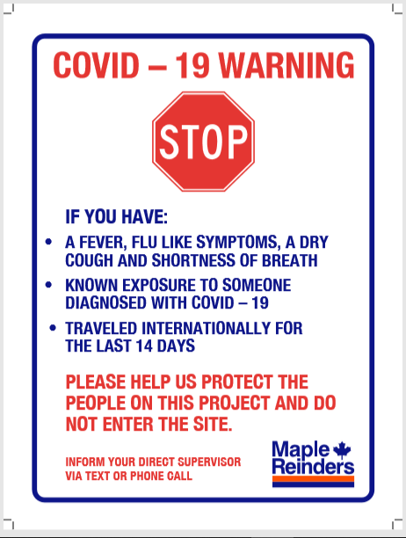

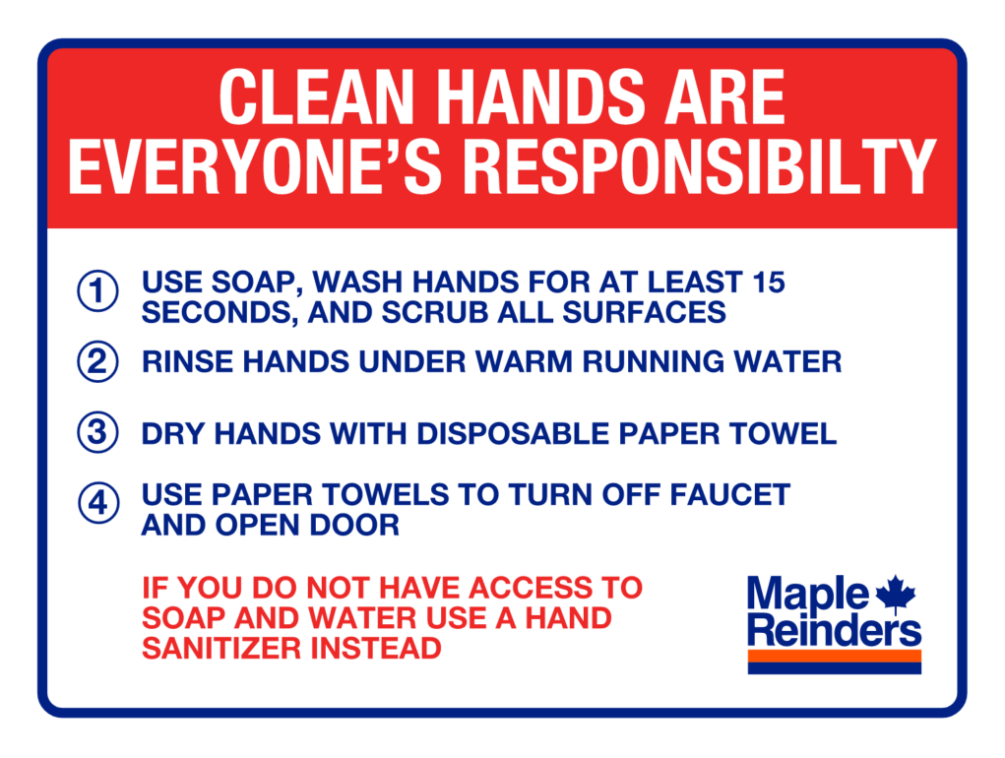

APPENDIX 3 – Personal COVID-19 Planning

Personal Health

  - Eat, rest well and exercise in moderation
  - Wash your hands frequently with warm water and soap
  - Cover your nose and mouth when coughing or sneezing
  - Minimize visitors at home
  - Check up on friends and family who live alone
  - Teach your children to wash hands frequently with soap and water
  - Stay informed – watch for updates from public health providers
  - Get the COVID-19 vaccine when available

Stay away from crowds

  - Stock up (not panic buy) on basic items (food, water, medical supplies)
  - Shop at smaller stores with smaller line-ups
  - Shop at off peak hours
  - Consider pre-ordering groceries and then just pick up or have delivered
  - Pay bills electronically
  - Postpone family gatherings, outings, trips

Stay healthy at work and at home
  - Maintain contact with colleagues who may be working remotely
  - Use Teams or Zoom to talk face to face (virtually)
  - Continue to look after your physical and mental condition
  - Maintain a healthy diet

APPENDIX 4 –COVID-19 Active Screening

Sign-In Sheet

(See PPM for your provincial form)

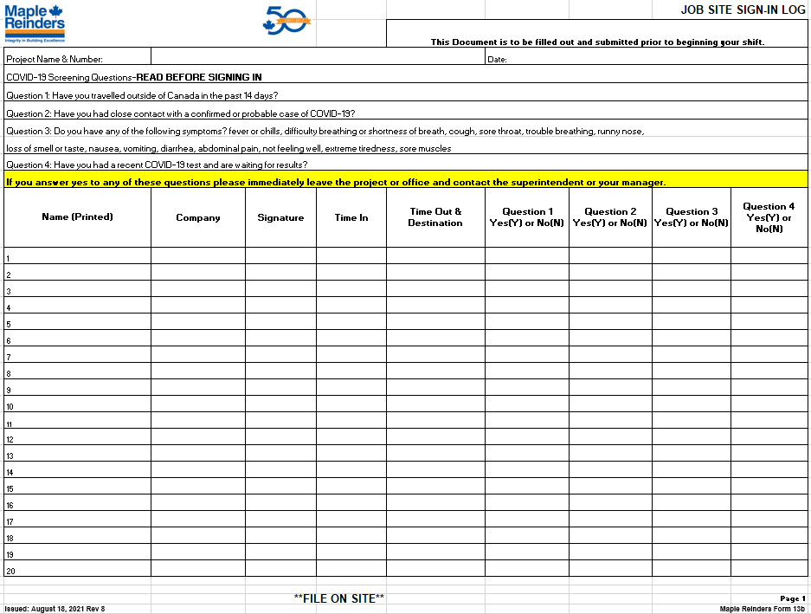

APPENDIX 5–COVID-19 Site Sanitation Checklist

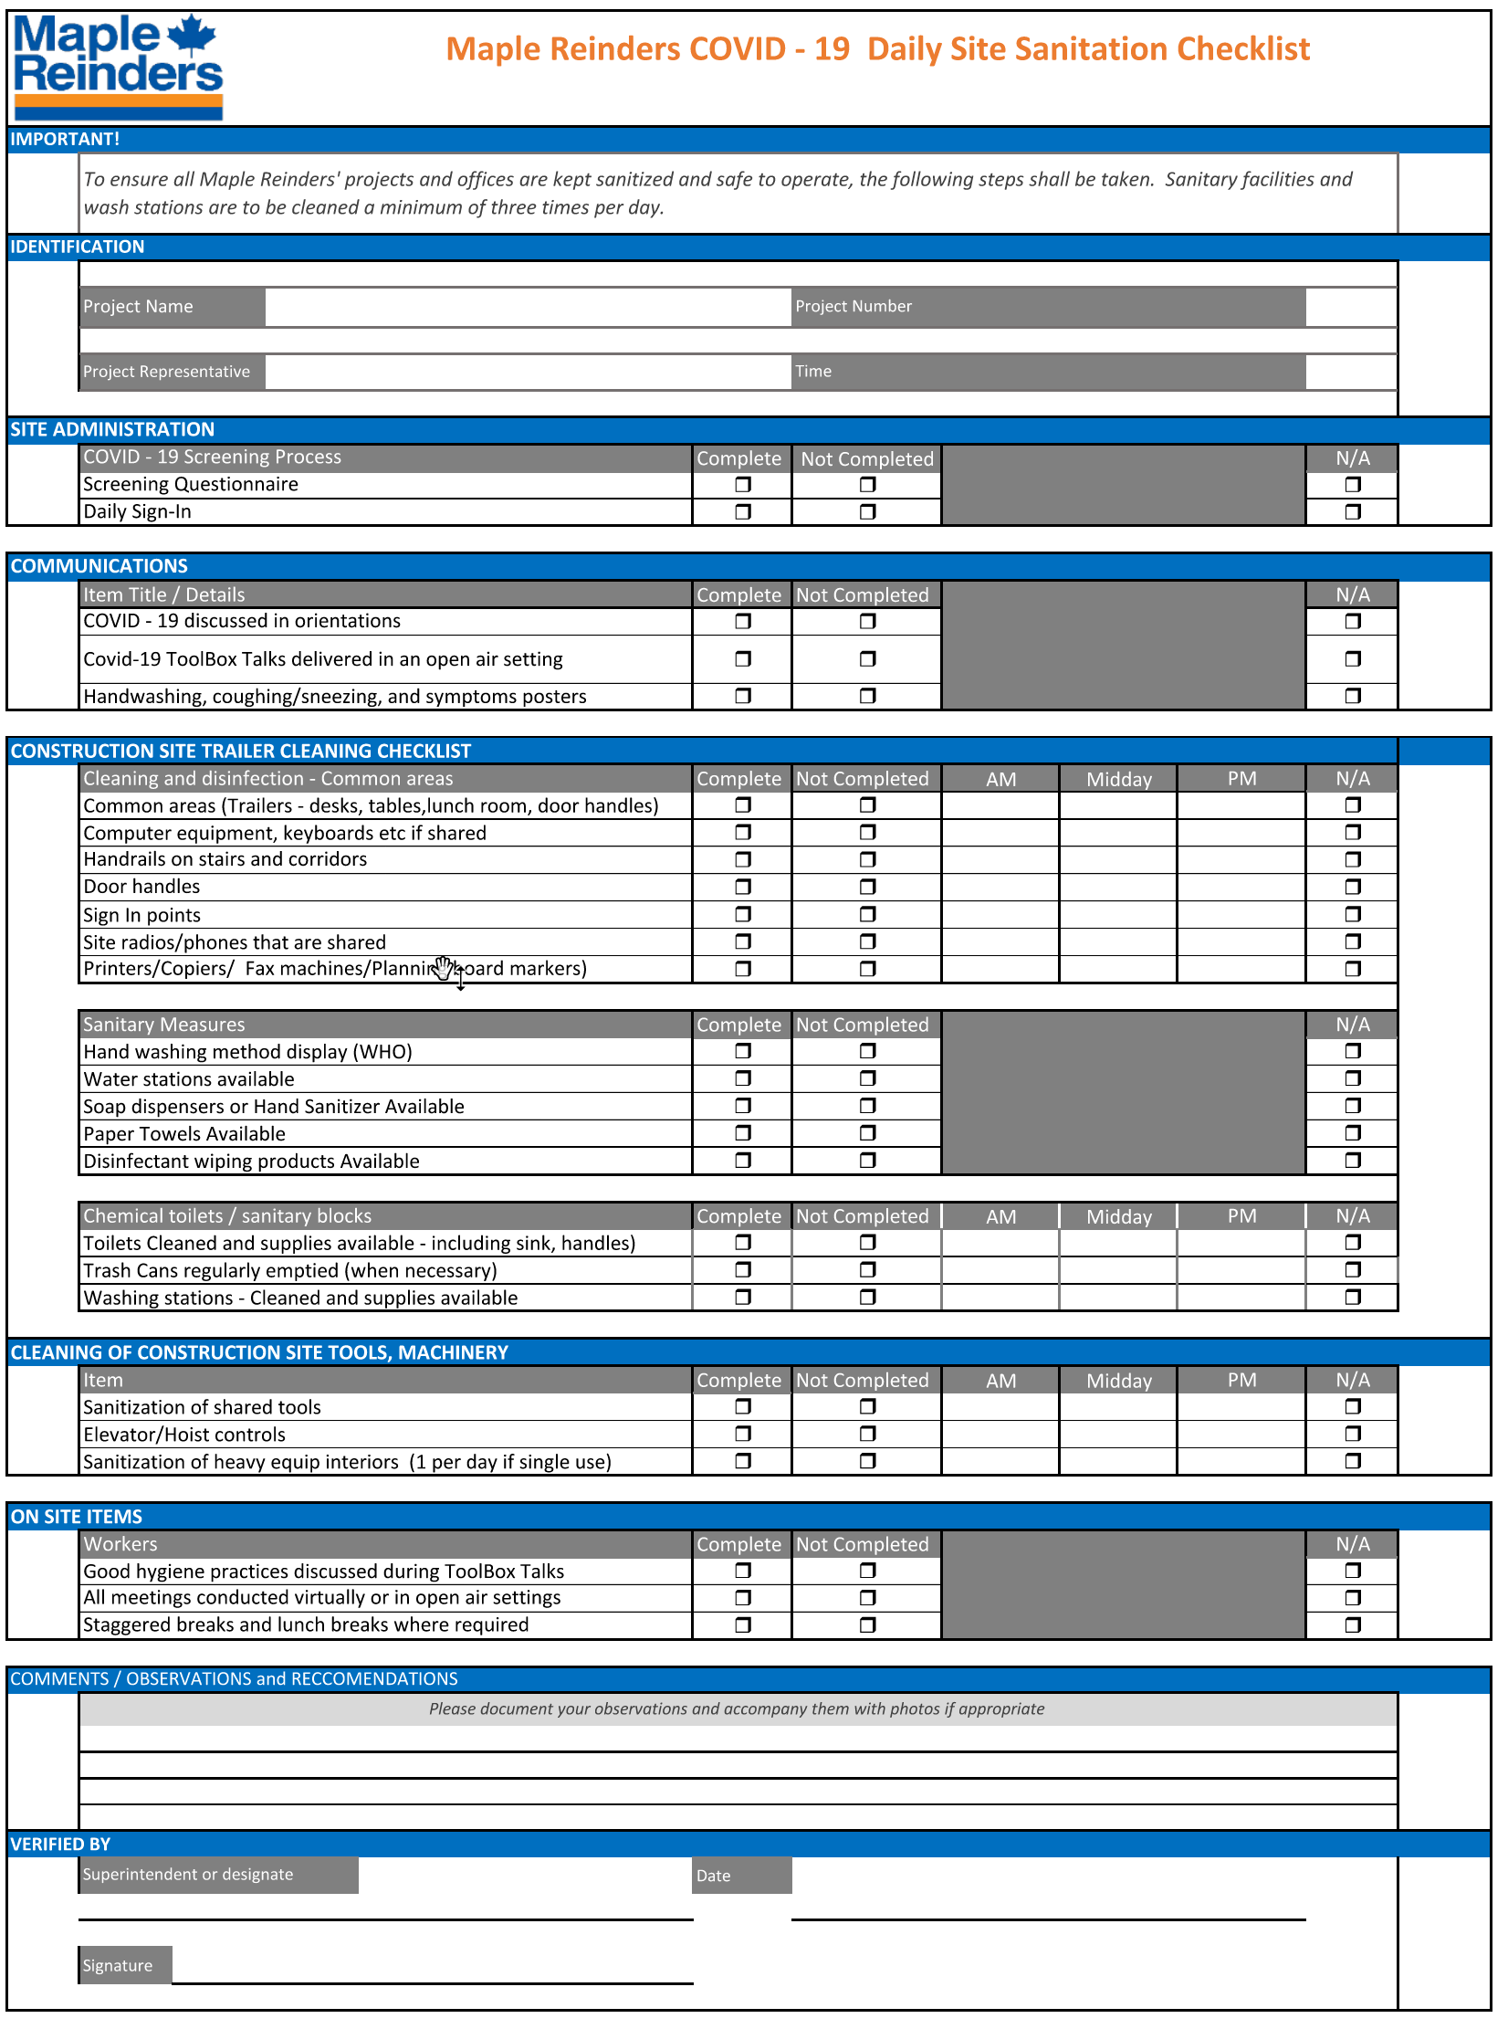

APPENDIX 6–COVID-19 Spare Vehicle Inspection Checklist

Vehicle Information
Vehicle: |  |  |  |  | Date Out: |  |  |  |  | DATE In:
License Plate: |  |  |  | Prov: |  |  | Km Out |  |  |  | Km In
Driver:
Checklist
Prior to Starting
Windshield (good condition?) | Yes | No
Washer fluid level (adequate for conditions?) | Yes | No
Tires & wheels (low, missing lug nuts?) | Good | Needs Repair
Leaks (visible leakage under vehicle?) | None | Needs Repair
Body condition (dings & scratches?) Indicate on reverse | Yes | Damage Noted
COVID19-Have you sanitized high touch areas in the vehicle? (Steering wheel, radio, arm rests, door handles etc.) | Yes | No
COVID19-Car pooling is not allowed in this vehicle.
After Starting
Check engine light (did it come on?) | No | Yes
Tire pressure confirmation (did it give a warning?) | No | Yes
Headlights (do they all work? Hi beams?) | Yes | No
Turn signals (do they all work?) | Yes | No
Brake lights (do they work?) | Yes | No
Upon Return
Vehicle cleanliness (appropriate condition?) | Yes | No
Fuel tank at least half full | Yes | No
Deficiencies reported | Yes | No
Repairs / maintenance performed? | Yes | No
Receipts attached? | Yes | No
Fleet Card & keys returned? | Yes | No
COVID19-Have you sanitized high-touch areas of the vehicle? (steering wheel, radio, arm rests, door handles etc.) | Yes | No
COVID19-Have you left enough cleaning produces in this vehicle for the next person? | Yes | No
Notes
SIGNATURE:

APPENDIX 7–COVID-19 Exposure Flowcharts

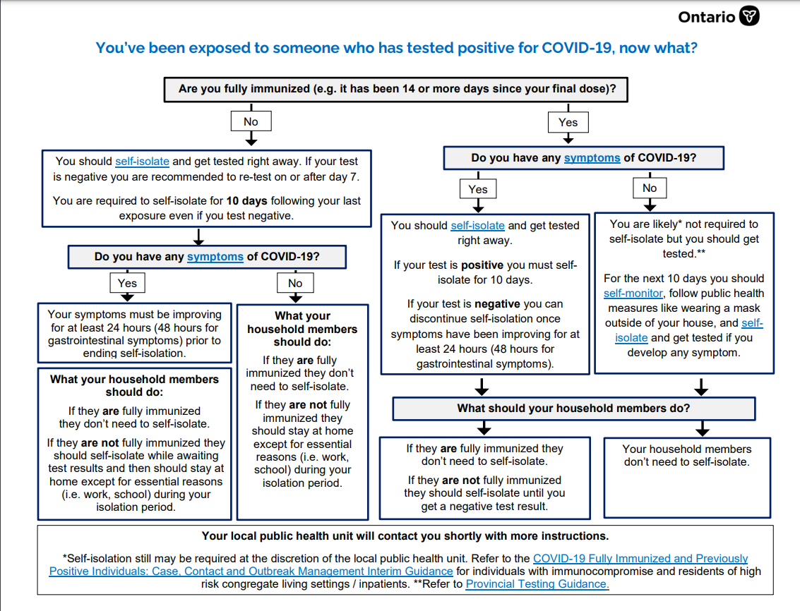

APPENDIX 8-Reopening Plans

(Follow your regional Reopening Plan)

